**Test 3 A and B**

Diana Elizabeth Torres López

TriOS College / Sault College

CSD214 Programming Concepts 2

Sarmad Mohammad

Wednesday, March 12th, 2025

**Test 3 A and B**

Test 3A

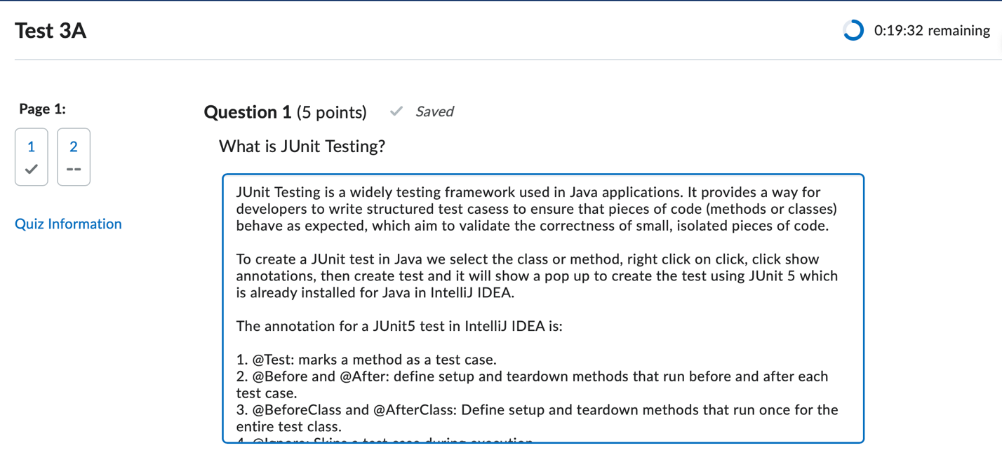

JUnit Testing is a widely testing framework used in Java applications. It provides a way for developers to write structured test cases to ensure that pieces of code (methods or classes) behave as expected, which aim to validate the correctness of small, isolated pieces of code.

To create a JUnit test in Java we select the class or method, right click on click, click show annotations, then create test and it will show a pop up to create the test using JUnit 5 which is already installed for Java in IntelliJ IDEA.

The annotation for a JUnit5 test in IntelliJ IDEA is:

1. @Test: marks a method as a test case.

2. @Before and @After: define setup and teardown methods that run before and after each test case.

3. @BeforeClass and @AfterClass: define setup and teardown methods that run once for the entire test class.

4. @Ignore: skips a test case during execution

JUnit also provides assertions. This set of assertion methods to verify expected outcomes.

Examples include:

1. assertEquals(expected, actual): checks if two values are equal.

2. assertTrue(condition): verifies that a condition is true.

3. assertNull(object): ensures an object is null.

4. assertThrows(exceptionClass, executable): verifies that a specific exception is thrown.

For example:

import org.junit.jupiter.api.Test;

import static org.junit.jupiter.api.Assertions.*;

public class CalculatorTest {

@Test

public void testAdd() {

Calculator calculator = new Calculator();

int result = calculator.add(3, 5);

assertEquals(8, result, "3 + 5 should equal 8");

}

@Test

public void testSubtract() {

Calculator calculator = new Calculator();

int result = calculator.subtract(10, 4);

assertEquals(6, result, "10 - 4 should equal 6");

}

}

In this example, The CalculatorTest class contains two test methods: testAdd and testSubtract.

Each method uses the assertEquals assertion to verify the output of the corresponding method in the Calculator class.

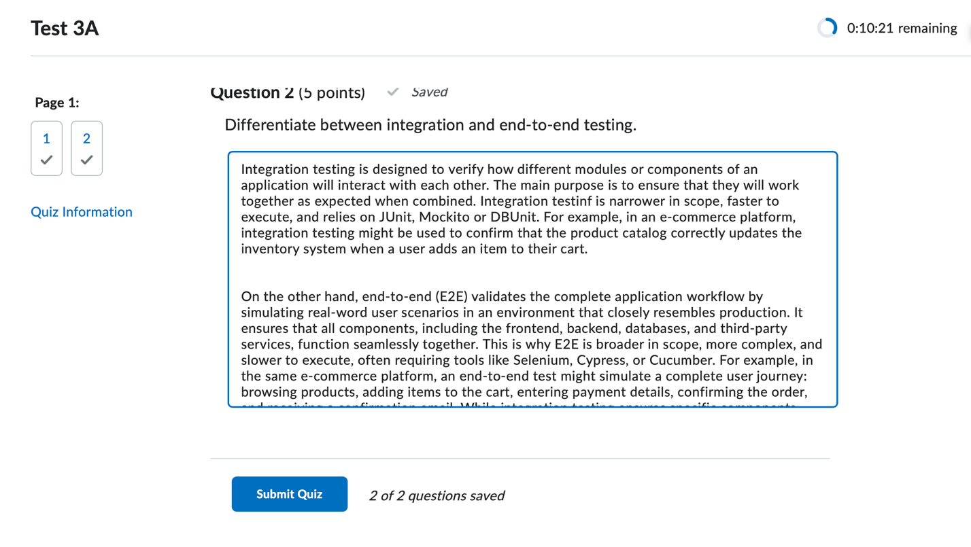

Integration testing is designed to verify how different modules or components of an application will interact with each other. The main purpose is to ensure that they will work together as expected when combined. Integration testing is narrower in scope, faster to execute, and relies on JUnit, Mockito or DBUnit. For example, in an e-commerce platform, integration testing might be used to confirm that the product catalog correctly updates the inventory system when a user adds an item to their cart.

On the other hand, end-to-end (E2E) validates the complete application workflow by simulating real-word user scenarios in an environment that closely resembles production. It ensures that all components, including the frontend, backend, databases, and third-party services, function seamlessly together. This is why E2E is broader in scope, more complex, and slower to execute, often requiring tools like Selenium, Cypress, or Cucumber. For example, in the same e-commerce platform, an end-to-end test might simulate a complete user journey: browsing products, adding items to the cart, entering payment details, confirming the order, and receiving a confirmation email. While integration testing ensures specific components work well together, end-to-end testing confirms that the system as a whole meets user expectations and performs reliably in real-world conditions.

Test 3B

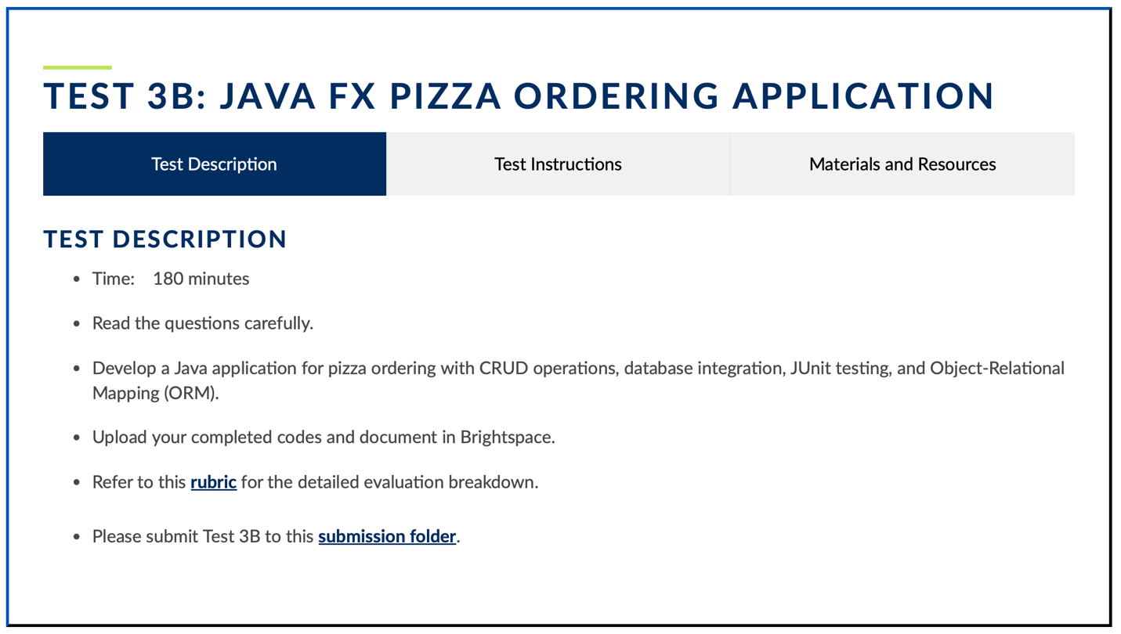

Test 3B Instructions.

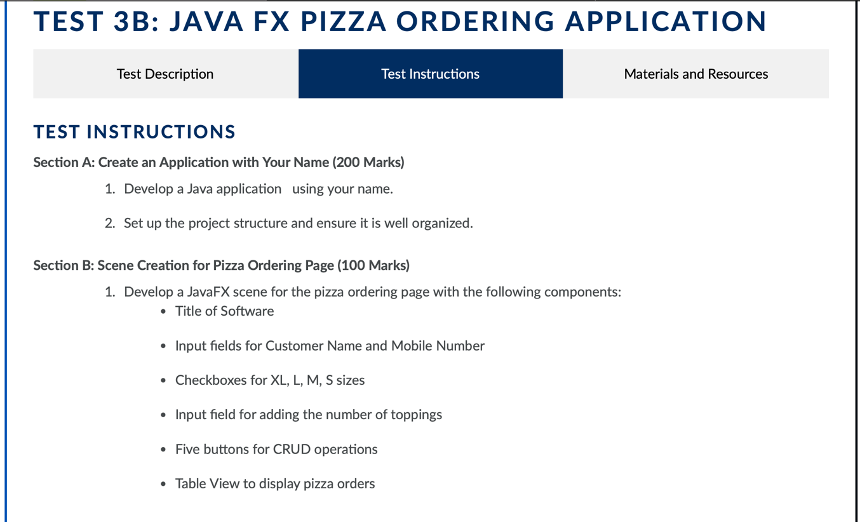

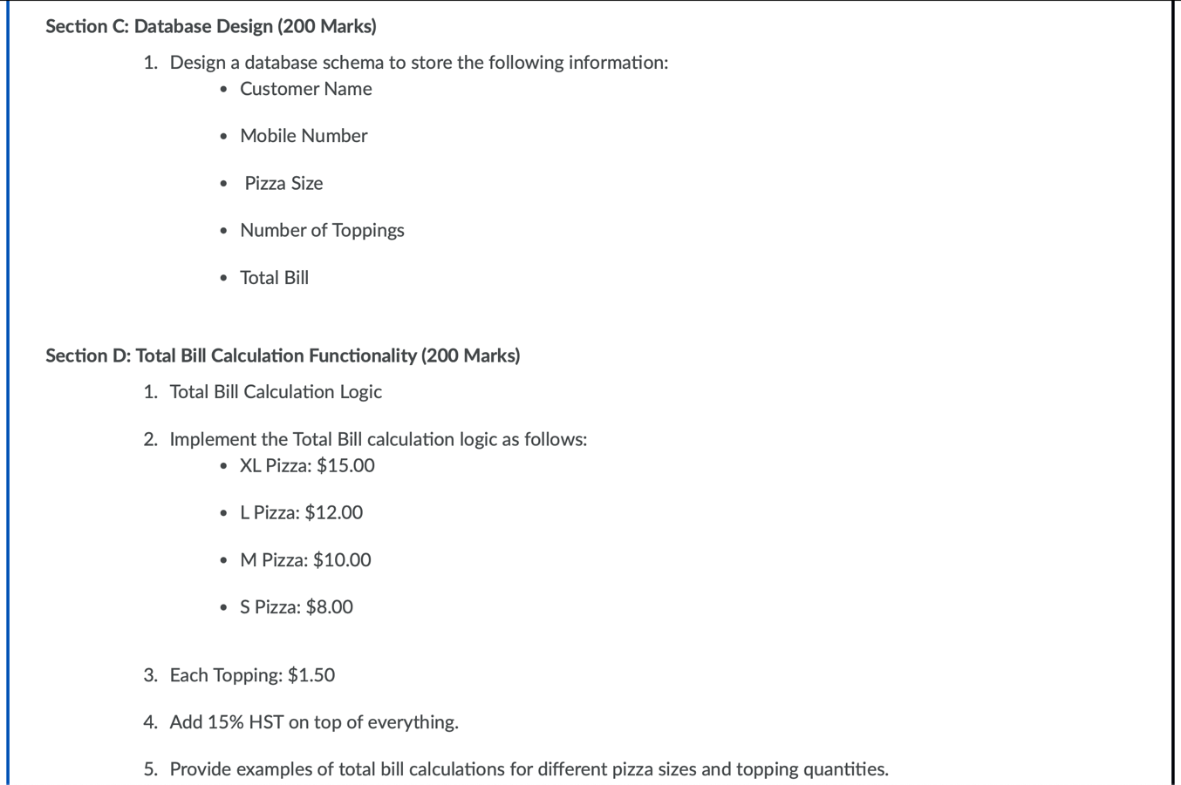

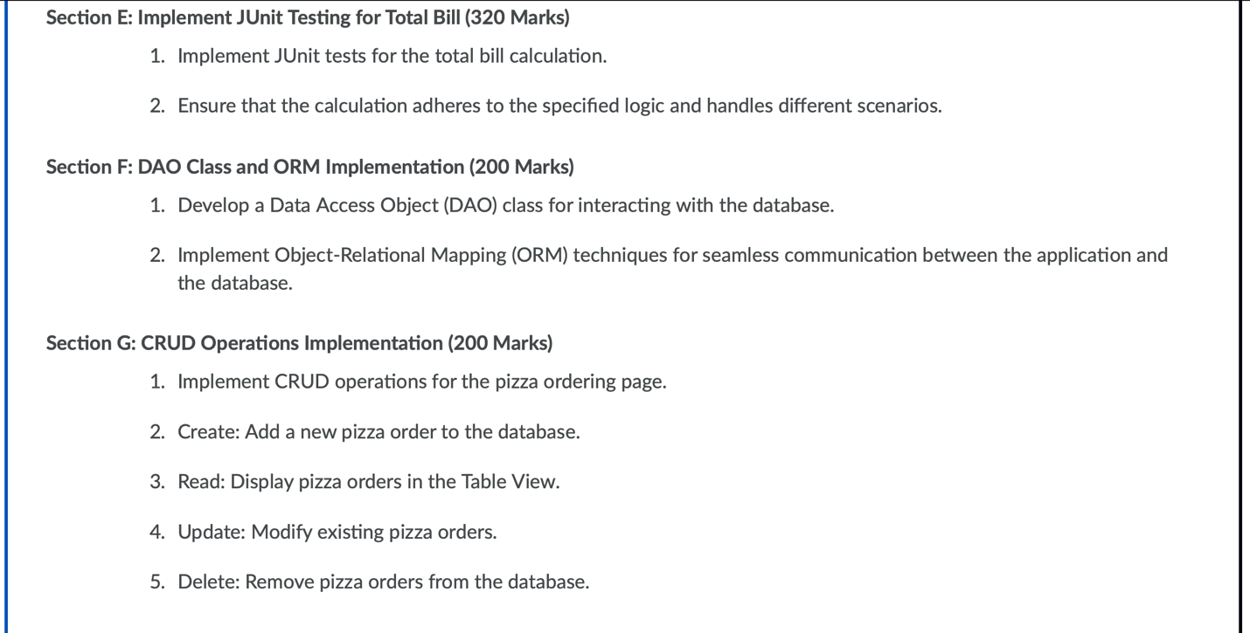

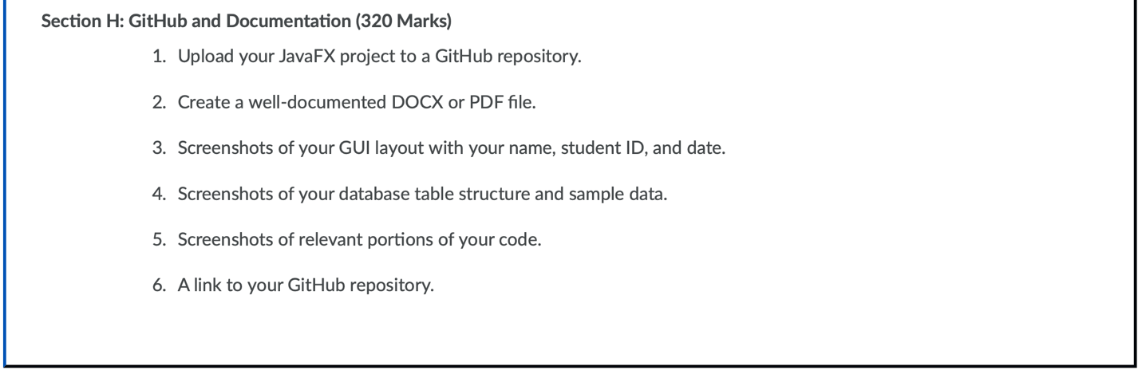

Database Design (200 Marks)

For this application, we first create the database to store all the information that will be handled. We will create two tables: Customers and Orders. The relationship between these tables will be established using a foreign key.

Customers Table: This table stores customer-related information:

customer_id: Primary key, auto-incremented.

customer_name: Name of the customer.

mobile_number: Mobile number of the customer.

Orders Table: This table stores order-specific information:

order_id: Primary key, auto-incremented.

customer_id: Foreign key referencing the Customers table.

pizza_size: Size of the pizza (XL, L, M, S).

number_of_toppings: Number of toppings selected.

total_bill: Calculated total bill, including HST (15%).

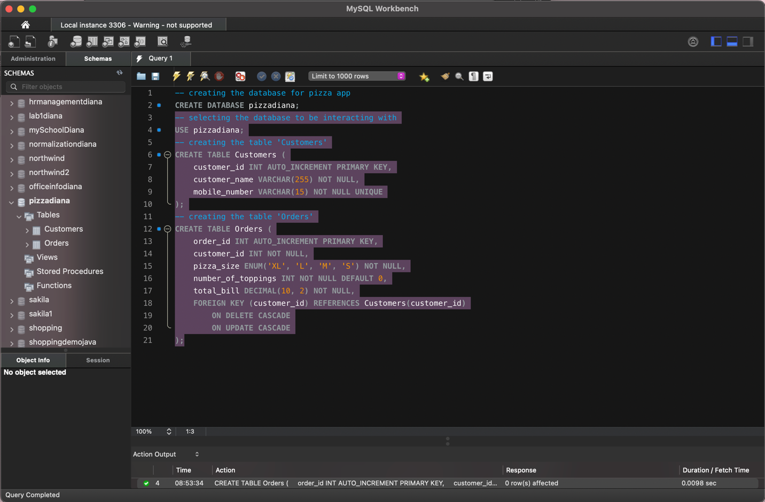

We create the JavaFX project on IntelliJ IDEA. We ensure it has the dependencies needed and we add the JDBC for MySQL.

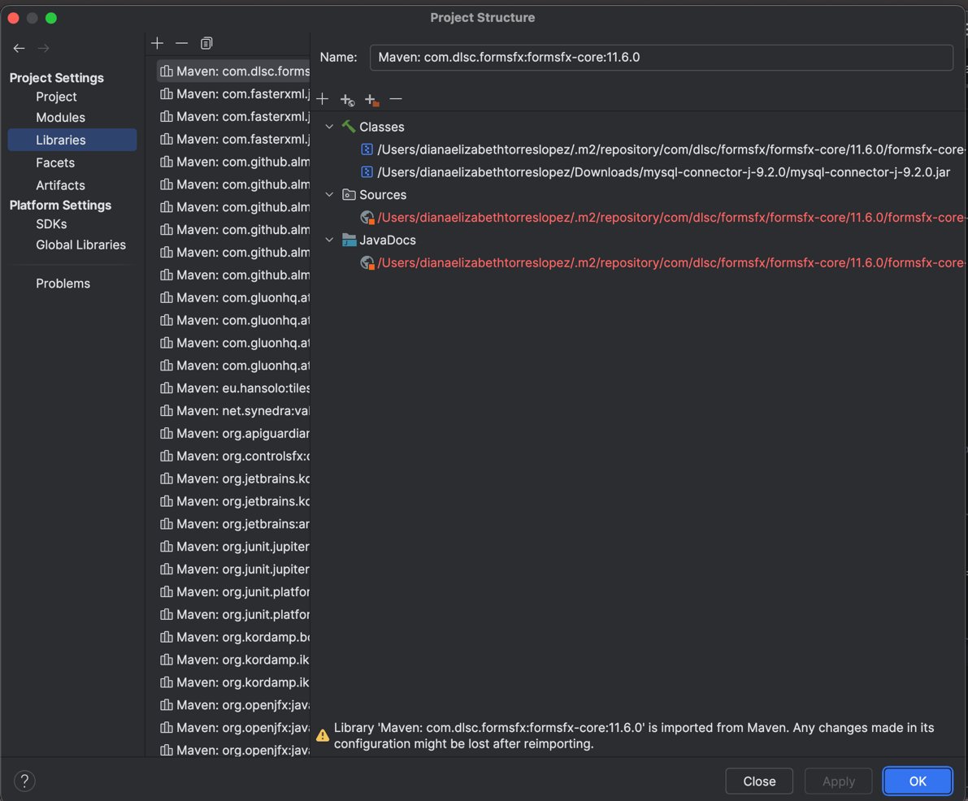

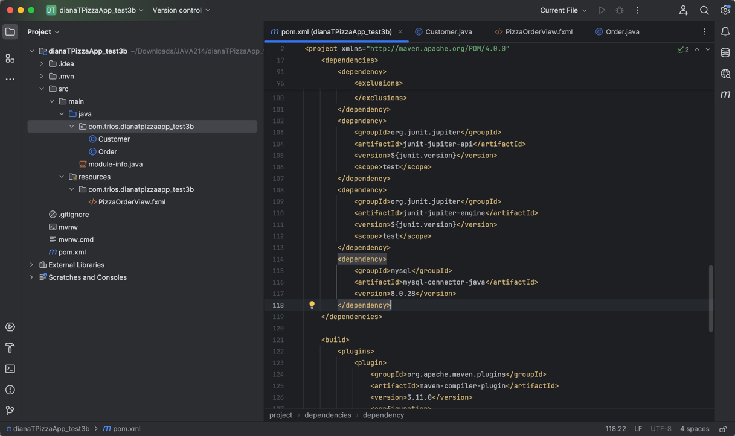

Then, we need to create the connection to the database created on MySQL Workbench by passing the credentials. Therefore, we can proceed to create the classes using ORM.

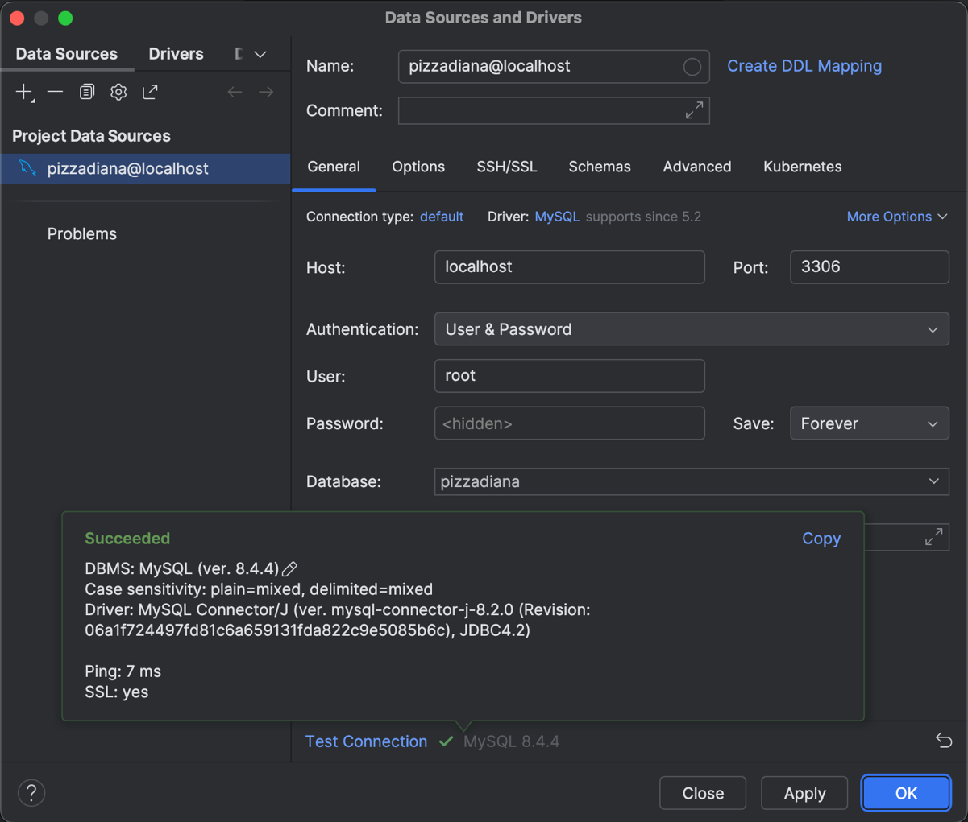

DAO Class and ORM Implementation (200 Marks)

Class Customer using ORM to the entity Customers in the database:

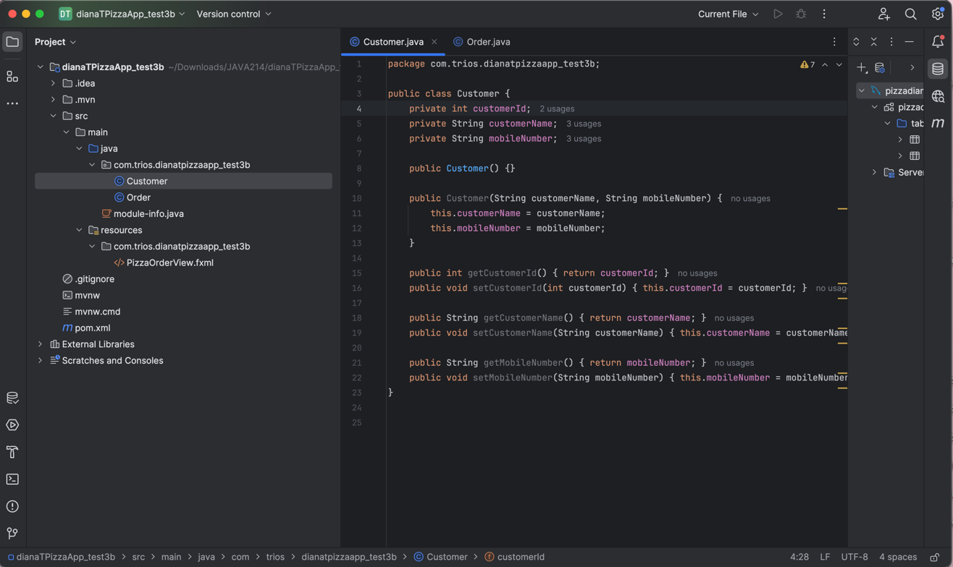

Class Order using ORM to the entity Orders in the database:

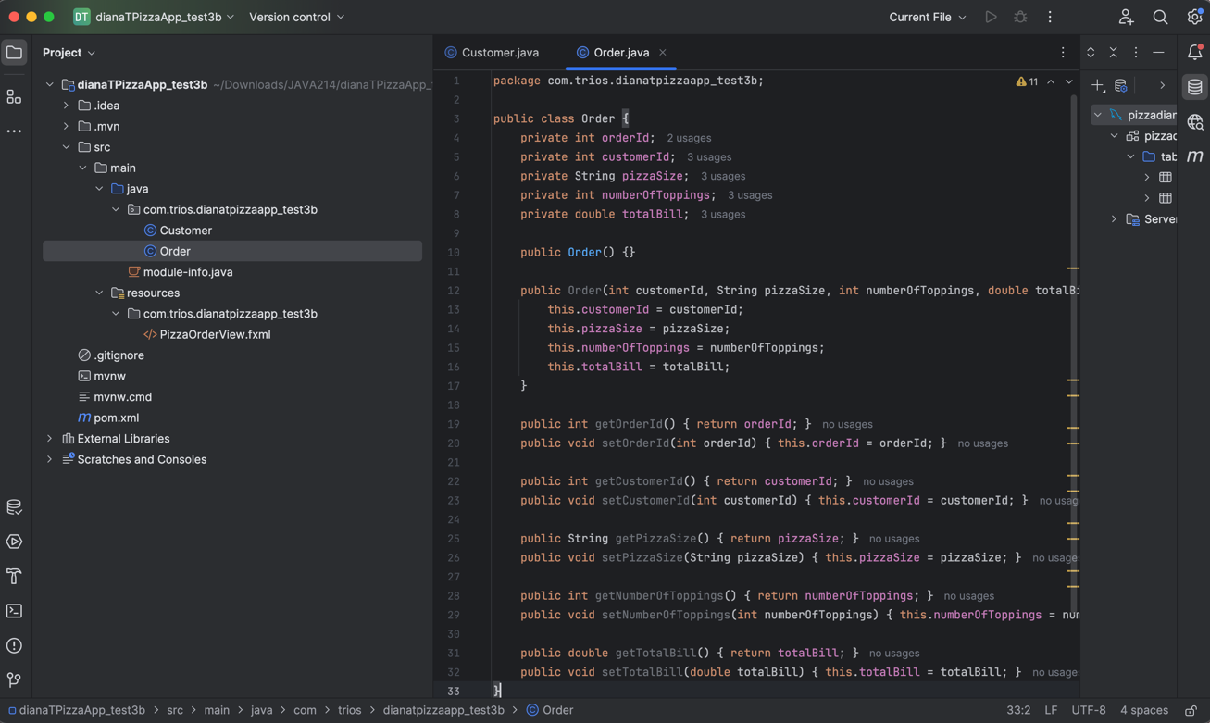

We create the class OrderDAO.

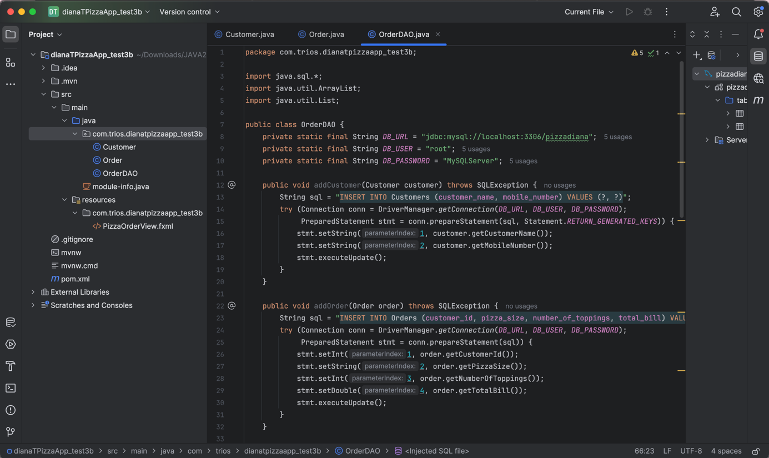

We create the class CustomerDAO.

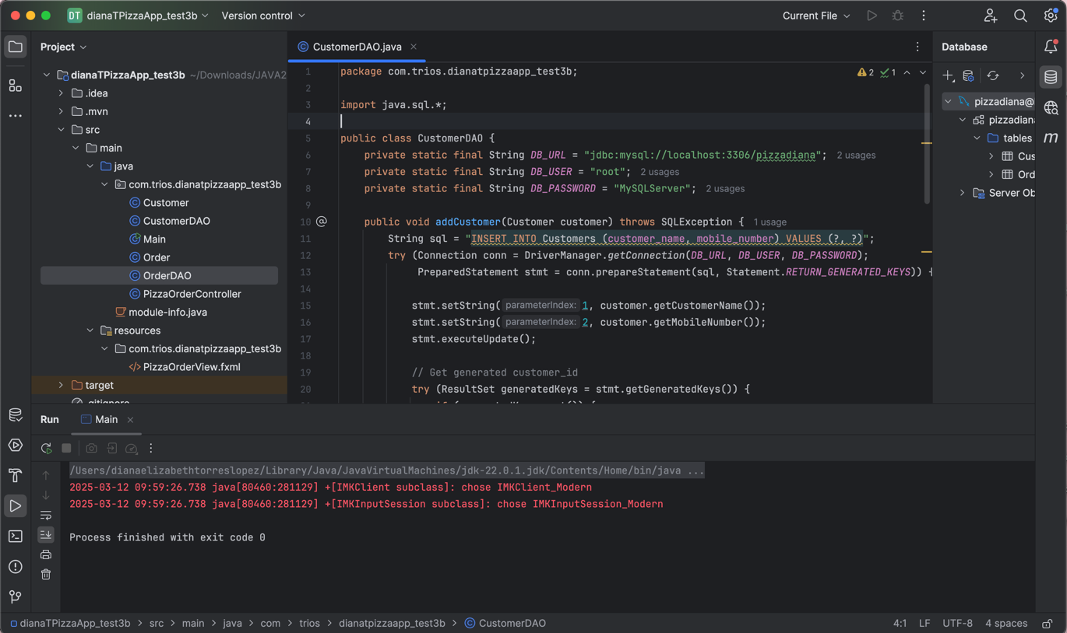

CRUD Operations Implementation (200 Marks)

Then, we create all the logic inside the controller class PizzaOrderController that will handle all CRUD operations.

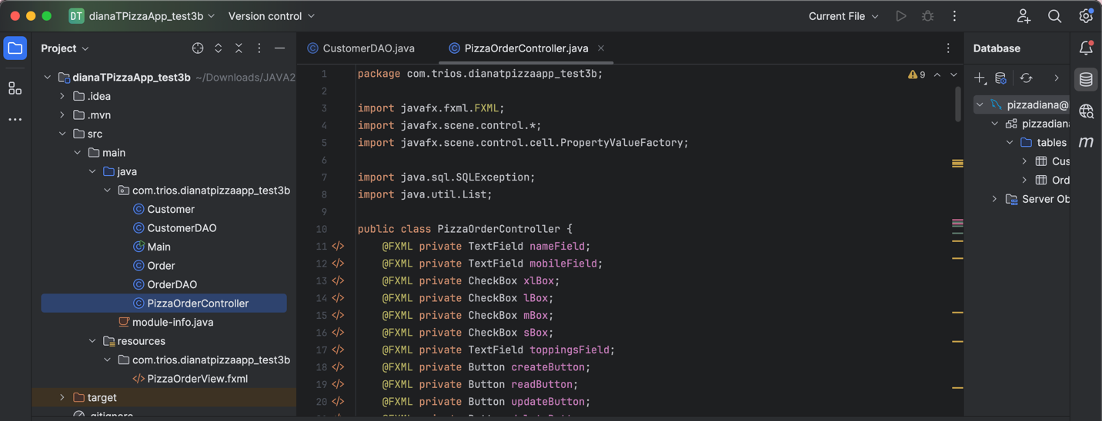

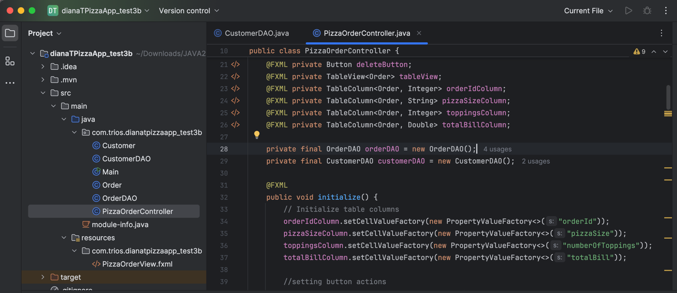

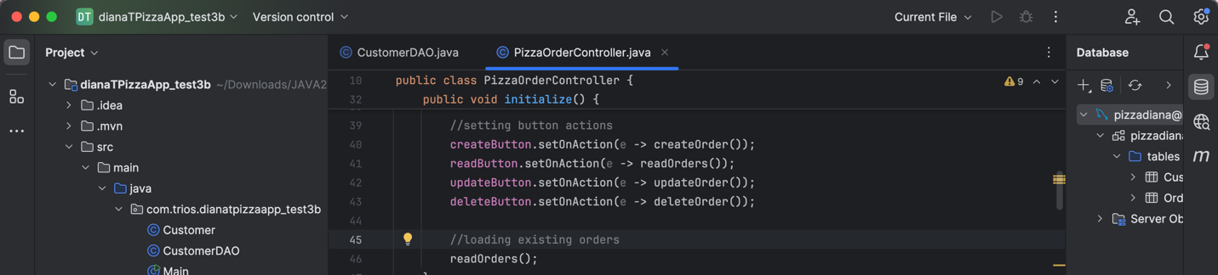

Create Order Logic:

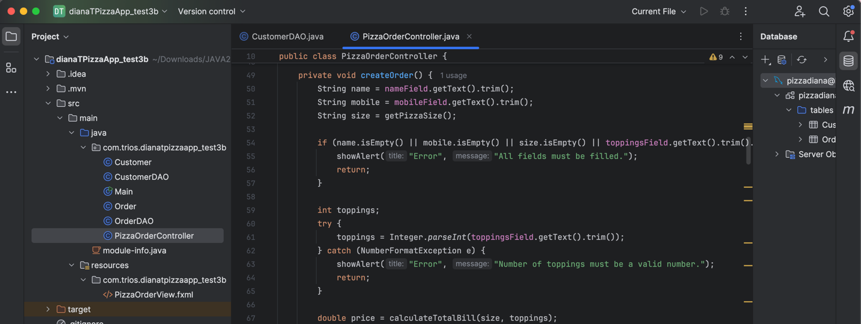

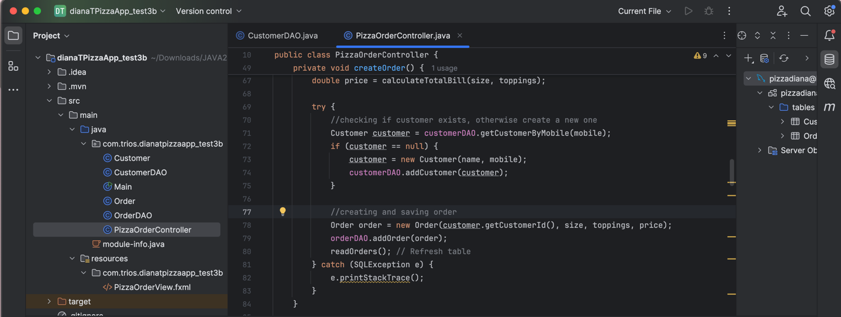

Read Order Logic:

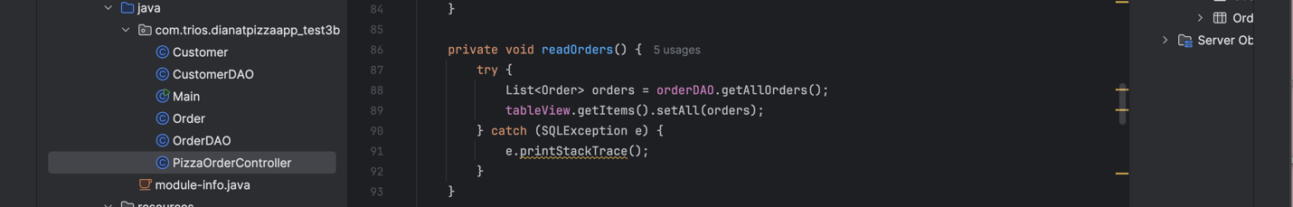

Update Order Logic:

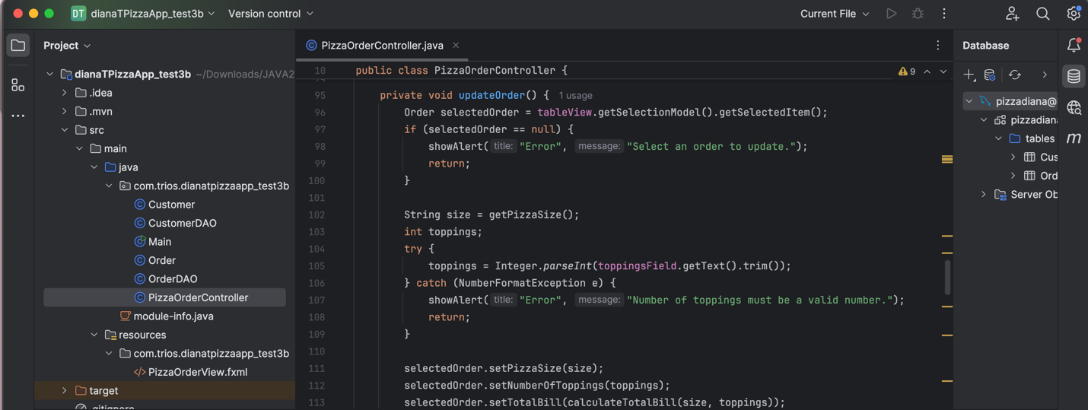

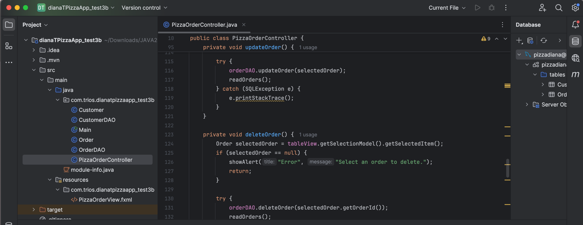

Delete Order Logic:

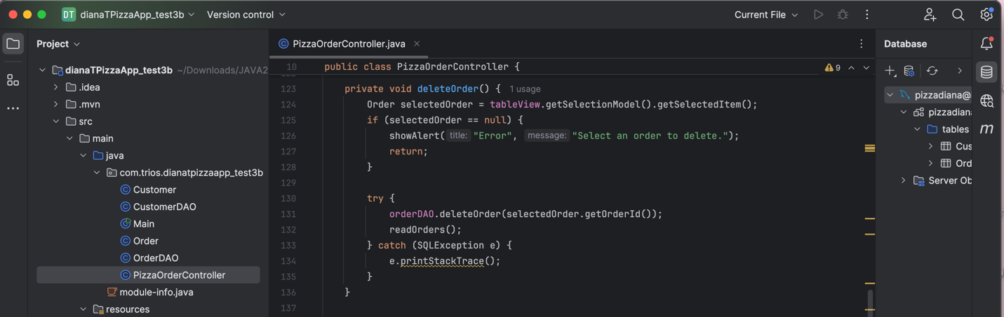

Total Bill Calculation Functionality (200 Marks)

Methods to handle the total bill and getting the price of each pizza size:

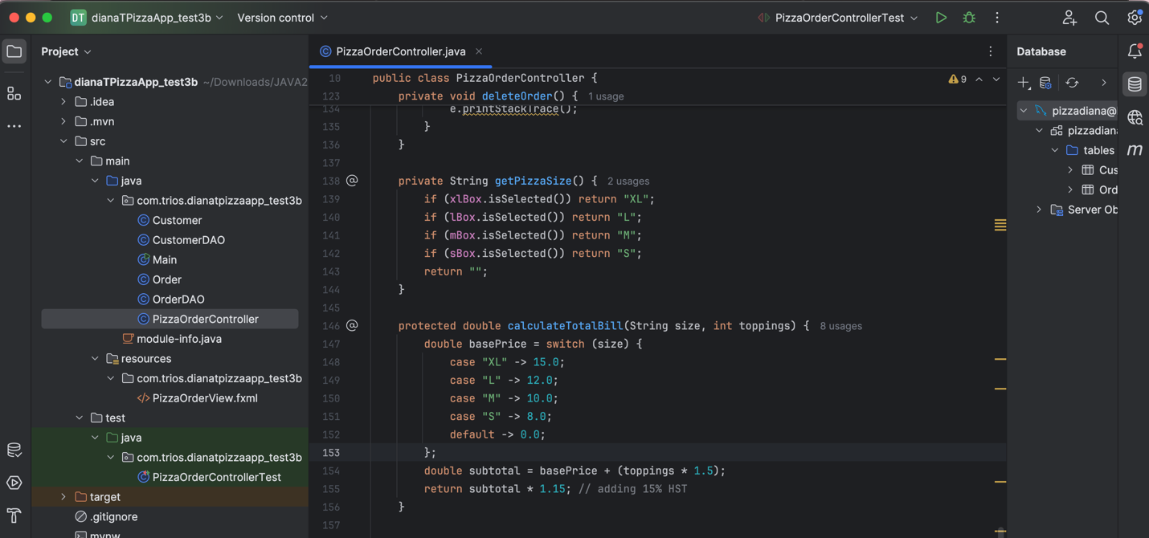

To handle and show any errors: 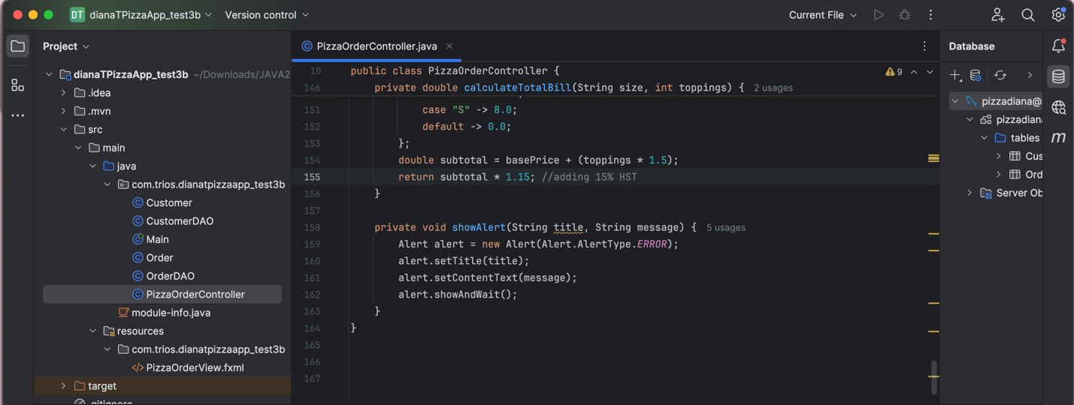

Scene Creation for Pizza Ordering Page (100 Marks)

All those methods created will be executed when the user clicks the buttons on the fxml file. We create the PizzaOrderView.fxml file.

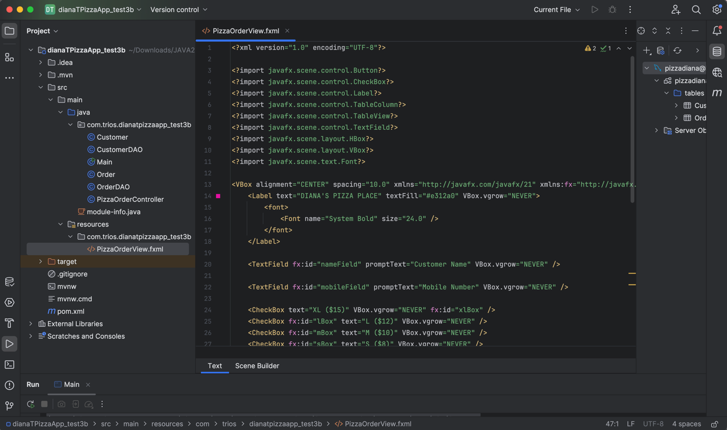

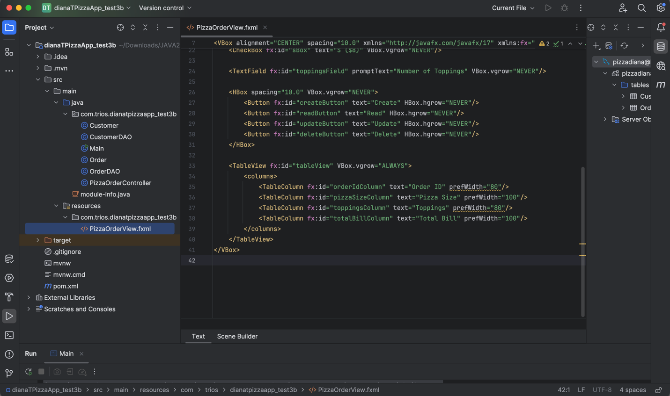

When we open it in Scene Builder, we can see what the user will interact with.

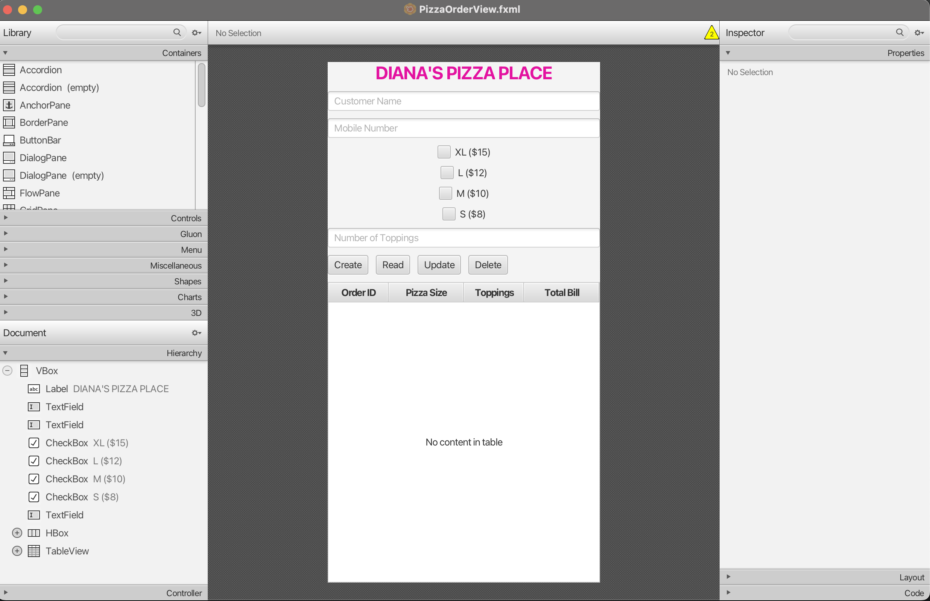

We add the checkboxes for the user to select the pizza size and the table view for them to perform CRUD operations.

Implement JUnit Testing for Total Bill (320 Marks)

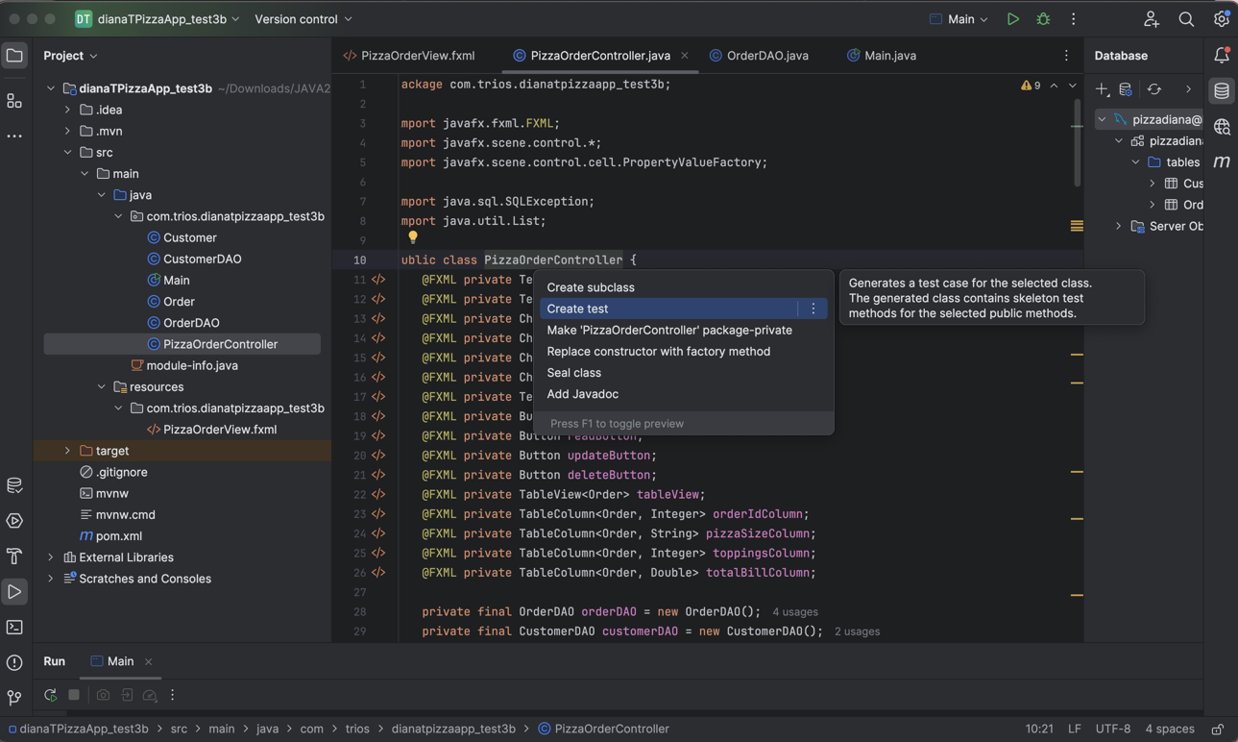

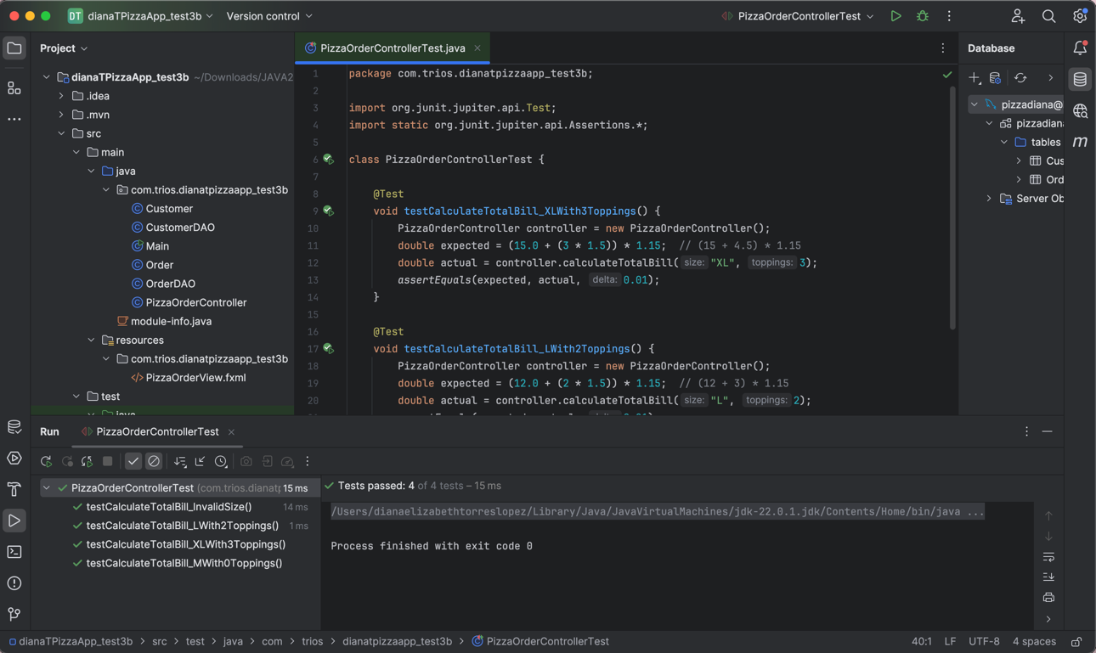

When running the test cases scenarios, we can see the method to calculate the bill passes.

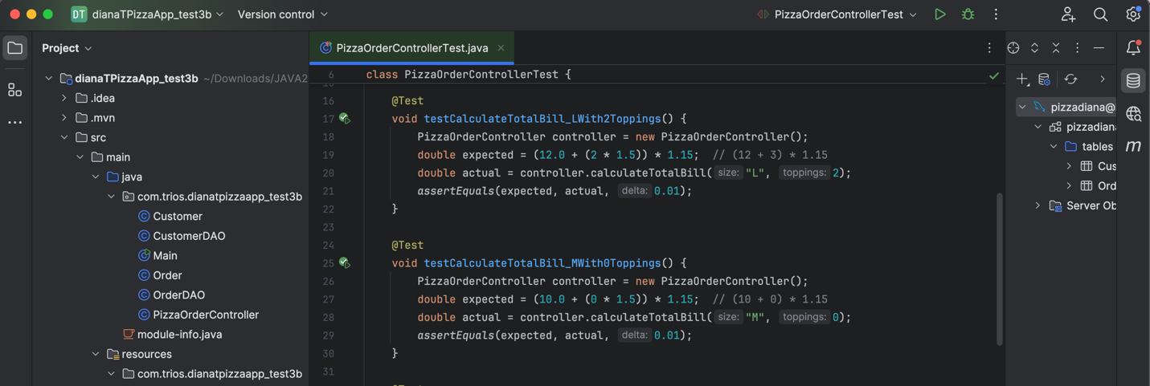

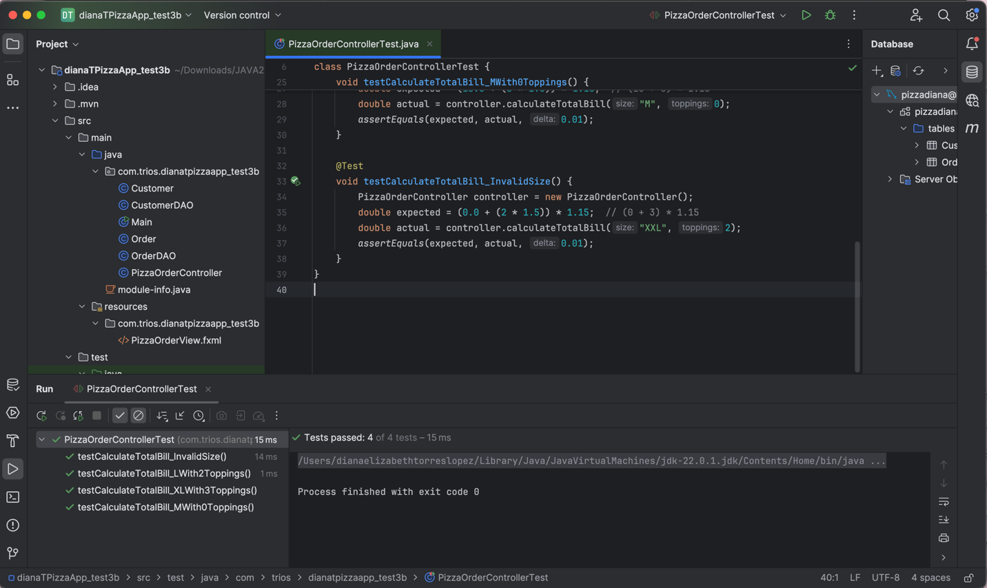

Create an Application with Your Name (200 Marks)

Main Class:

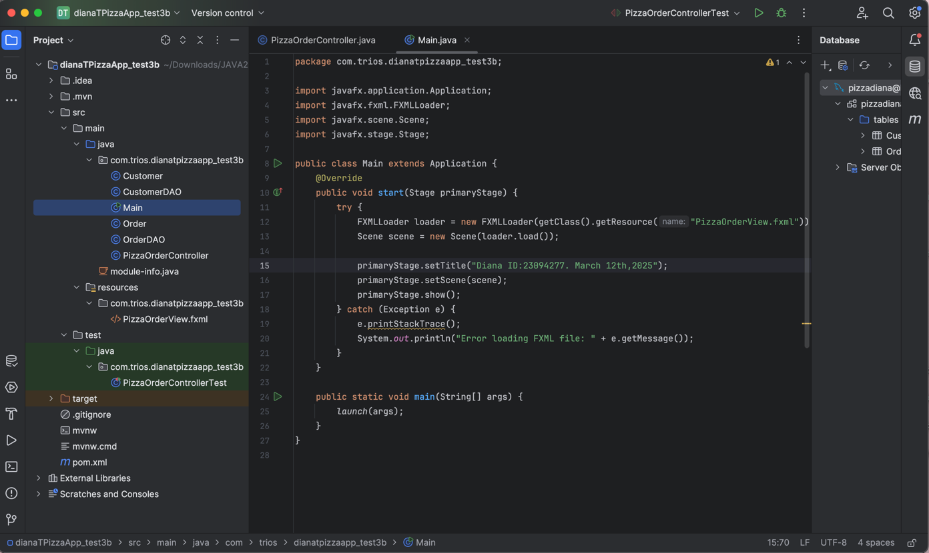

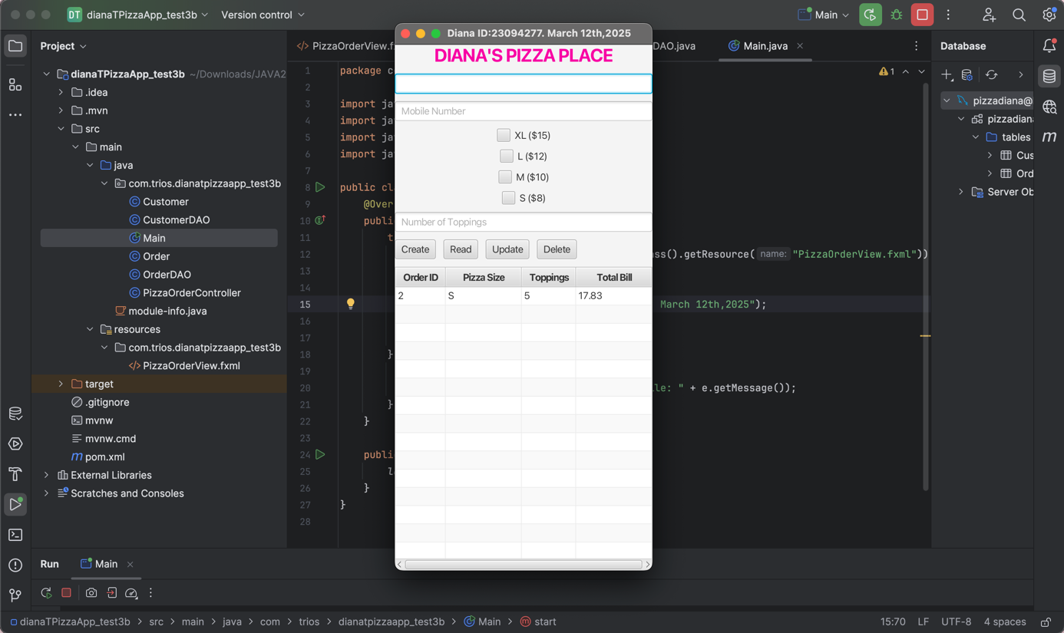

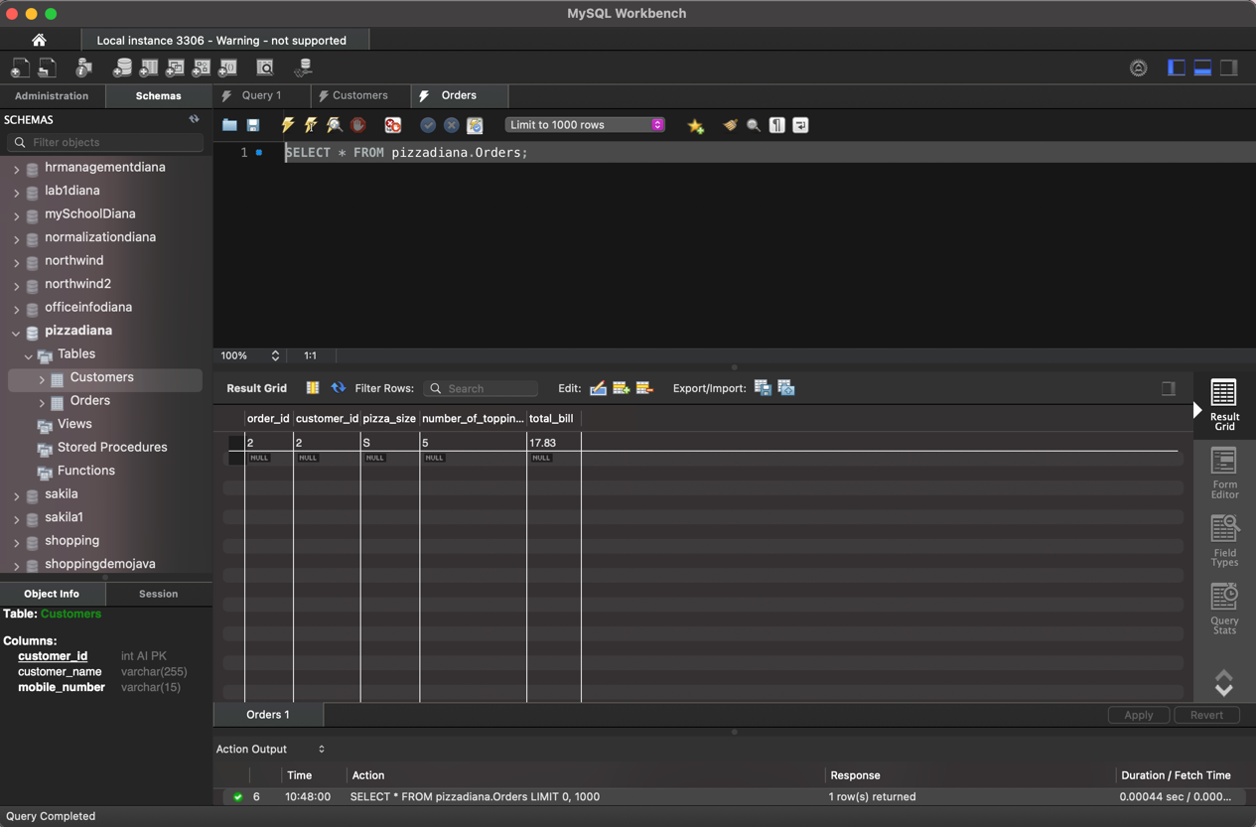

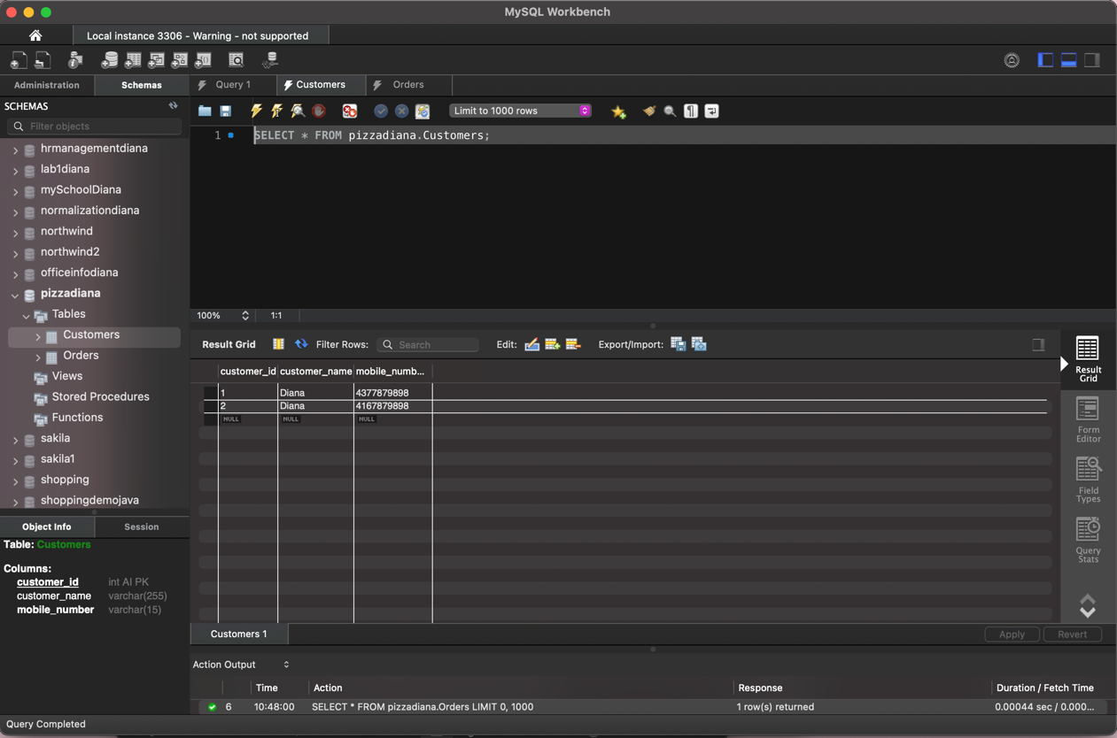

GitHub and Documentation (320 Marks)

GitHub Link: <https://github.com/dianadeliz/CSD214Test3BDianaT>